**Chap 12 HHE: From Hominin to Homo**

**Adam Purvis**

**Origins of Homo**

- Appeared approx. 2.3mya in Africa

- Larger brains, smaller teeth

- Limbs like Australopithecus… rapid development patterns

- Thinner enamel, more rounded skulls, face is smaller with less protruding, jaws and jaw muscles reduced in size.

- Smaller brained individuals 🡪 h. habilis; robust species with larger brains 🡪 h. rudolfensis

**Climate**

- Pleistocene started 1.8mya with a cooling trend the last 6mya

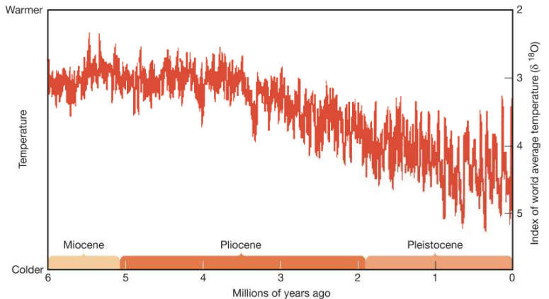

**H. ergaster**

- 1.8 - 0.6mya; evolved from early Homo; found in Kenya, Ethiopia, Tanzania, South Africa; **AFRICAN**

**Morphology**

- Skull differs from modern humans and earlier hominins.

- Human-like, Derived: shorter and less prognathic face, taller skull, smaller jaws, postcanine teeth, reduction of roots in premolars

- Earlier-hominins, ancestral: marked narrowing behind the eyes, receding forehead, no chin

- Stuff NOT in hominins or humans: Horizontal ridge at back of skull (occipital torus), large browridges

- Adapted for life in a drier environment.. better adapted for tearing and biting and less to heavy chewing

- Substantially larger brain than earlier hominins

- Robust, heavily muscled

- Reduced sexual dimorphism 🡪 males only 20-30% larger than females

- May not have spoken language

- Fullty committed to life on ground… was the first hominin that could run for long distances

**H. ergaster: Tools and Subsistence**

- Between 1.6-1.4mya, H.ergaster improved Oldowan tools, adding the stone biface, a **Mode 2** technology

- Archeulan industry 🡪 Africa and Western Eurasia

- A common type of biface - the hand ax

- Other bifaces; cleavers, picks

- Hand axes were likely used to butcher large animals; digging up tubers, burrowing animals, water; stripping at bark from tress to get to nutritious cambium layer; hurling prey at animals; dispensing flake tools

- these tools didn’t change for approx. 1 million years until they were replaced 300kya

**Meat Eaters**

- H. ergaster ate meat regularly due to high frequency of hand axes, cut marks in animal bones from stone tools, dental morphology of H. egaster as well as intestinal parasites

- Intestinal parasites - tapeworm *Taenia*. Get into undercooked meat, when consumed, they produced eggs in the intestines of pigs or humans

- Don’t know if we obtained meat from scavenging or hunting

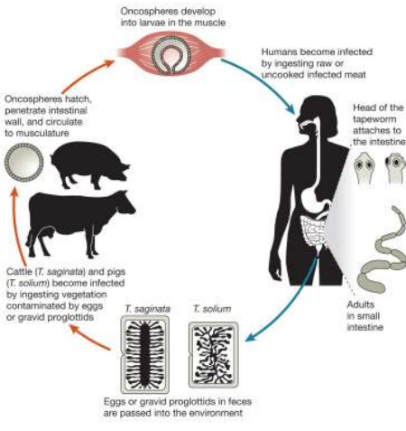

- likely controlled fire… sites with baked earth dated to about 1.5mya; however could be a natural fire

- Soil under campfires reaches higher temperatures than does soil under grassfires and yields bowl-shaped layers with highly oxidised and highly magnetised samples

**Dispersal out of Africa**

- H. ergaster occupied almost all of Africa and extended its range into Eurasia

- Around 1.8mya, hominins had reached the Caucasus mountains of the republic of Georgia

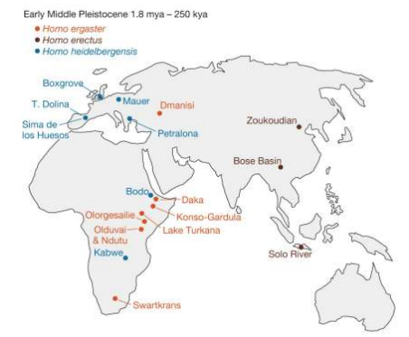- This was determined by the discovery of hominin skulls, oldowan tools

**H. erectus**

- Arrived in eastern Asia during the Lower Pleistocene

- 1.8 to 1.6 mya in Java, Indonesia

- Thicker skull, more massive face, more pronounced occipital torus and brow ridge, sagittal keel (longitudinal V-shaped ridge along the top of the skull than h. ergaster

- Used mostly Mode I tools, Mode II tools used in rare circumstances 🡪 perhaps this was due to weaker cognitive ability

**Early Middle Pleistocene Climate**

- World’s climate became colder and more variable during this time (900 to 130kya)

- Glaciers covered North America and Europe, arctic conditions prevailed.

- During short interglacial periods, the world was dry, Africa and Eurasia were separated by a massive desert

- During interglacial periods, the world was much wetter, and animals moved from Africa to Eurasia

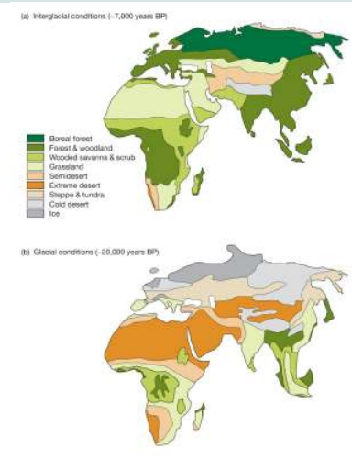

- Little movement of animal species between Africa and Asia during glacial periods. Animal species moved mainly east and west during this time

- When the world was warmer, grasslands and savannas placed most deserts, and animals were able to move between Africa and Eurasia much easier

**H. heidelbergensis**

- 900 to 130kya Africa and Western Eurasia

- Hominins with much larger brains and more modern skulls

- larger brains, larger brow ridges, no chin, prognathic face

- bodies more robust than modern humans

- vertical sides, higher foreheads, more rounded back

- refers to all of the middle Pleistocene hominins of Africa and western Eurasia

- Possibly co-existed with H.erectus in east Asia

**Big Game Hunters**

- Wooden spears found in an open coal pit mine in Germany, large number of fossilized bones from wooly mammoths found in France

- Butchered animal bones

- Utilized a variety of plant and animal resources 🡪 ate plant foods like oak acorns, water lily seeds and water chestnuts, also ate numerous animals.

**Mode III Tools**

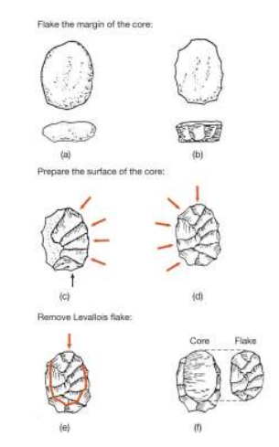- at 300kya, hand axes were becoming less common, repleaced by tools that were manufactured by the production of sizable flakes which were then further shaped or touched up  
- Flake margin of core; prepare surface of core; remove Levallois flake   
- Some tools were hafted (attached to a handle).. greatly increases efficiency as humans can apply more force to the tools

**H. floresiensis**

- Indonesian island of Flores 16-74kya

- Small bodied and small brained hominin

- Popular culture will have you believe that these are hobbits

- Arms long compared to legs, large feet, lack arch characteristic of humans

- Used sophisticated stone tools

- selection favors smaller body size on small islands because such island have less predation and more limited food supplies, also little gene flow

- Were they diseased? -- Laron syndrome results from a mutation to a gene that greatly reduces sensitivity to growth hormone and is associated with very small body size

**Western Asia - The Neanderthals**

- During the middle Pleistocene morphology of h. heidelbergensis diverged from morphology of contemporaries in Africa and asia

- Neanderthals - western Eurasia hominins who dominate the fossil record from 127 to 30kya

- large browridges, short muscular bodies, low foreheads

**Climate**

- Fluctuating climate, glacial and nonglacial periods with an overall cooling trend

- Eurasia had frigid grasslands with many large mammals

**Morphology**

- Large grain; larger than homo sapiens

- More rounded head, long and low skull

- Big faces, large browridges

- Small back teeth with large, heavily worn front teeth.

- Distinct taurodant roots (pulp cavity expands so that roots merged partially or completely to form a single broad root

- incisors large and show very heavy wear

- Robust, heavily muscled bodies; short and stocky

- Thicker leg bones than modern humans, loadbearing joints larger, shoulder blades had more muscular attachments, rib cage larger and more barrel shaped

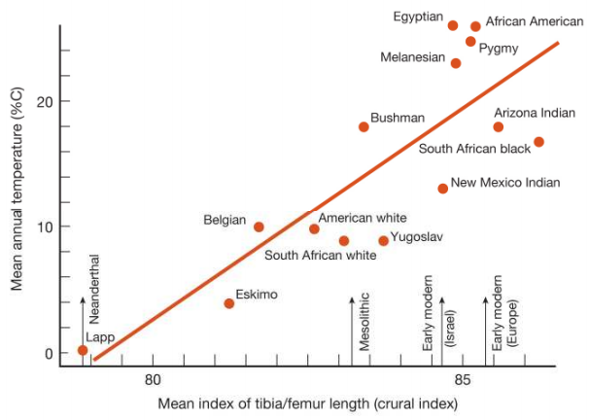

- Longer arms and legs in warmer climates than in colder climates

**Language?**

- by recording positions of several anatomical landmarks on the basicranium (bottom of the skull), scientists recorded a less humped profiles, suggesting that neanderthal’s capacity for language was limited

**Mode III Tools**

- Neanderthals hunted with these using tools from the **Mousterian industry** (flakes struck from prepared cores)

- Hunted red deer, fallow deer, bison, aurohs, wild sheep, goats, horses… hippo, rhinos, elephants

**Homes**

- Little evidence for shelters or organized camps at Neanderthal sites

- many Neanderthal cave sites are very well preserved, but this doesn’t mean that they preferred these kinds of sites, it just means they were really well preserved, protected from erosion

- Evidence suggests they didn’t build shelters, they used caves as home bases

**Burial of Dead**

- Neanderthals frequently buried dead to protect t corpses from dismemberment from scavengers

- Unlikely that it was ceremonial or religious

**Personal Ornaments**

- May have used painted sea shells as personal ornaments

- Also had body pigmentation

**Life of the Neanderthal**

- Lived short, difficult lives

- By assessing the degree of aging sutures (fused bones that form tigh, wavy joints), we can determine how old an individual was at death

- Few Neanderthals lived beyond 40 to 45 years

- Suffered debilitating diseases and/or injury such as arthritis, gum disease, stab wounds, withered limbs, lesions, deformities

**The Road to homo sapiens?**

- h. heidelbergensis evolved into h. sapiens in Africa approx. 200kya

- African hominins more similar to modern humans than Neanderthals were

**Sources of Change?**

- Europe may have been invaded repeatedly by hominins from Africa during the middle Pleistocene

- Continuous occupation and in-place occupation has lead to makers of mode I tools evolving slowly into the makers of mode II tools, and into mode III tools and so on

- Could also be due to the replacement of one hominin species by another

- Europe and western Eurasia were subjected to repeated invasions by hominins from Africa

- During glacial periods, homini populations in western Eurasia may have shrunk or disappeared all together

- Archaelogical evidence of tool types show that these objects originated in Africa and spread around the world

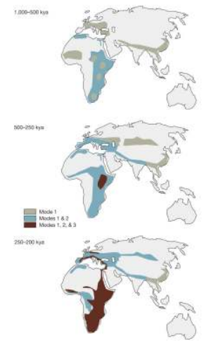

**Lumpers and Splitters**

- Anthropologists strongly disagree about how to classify middle Pleistocene hominins

- Hominins in Africa and Eurasia were one, single interbreeding population throughout the Pleistocene

- Hominins split into several new species as they migrated out of Africa during the Pleistocene